MainWindow.xaml

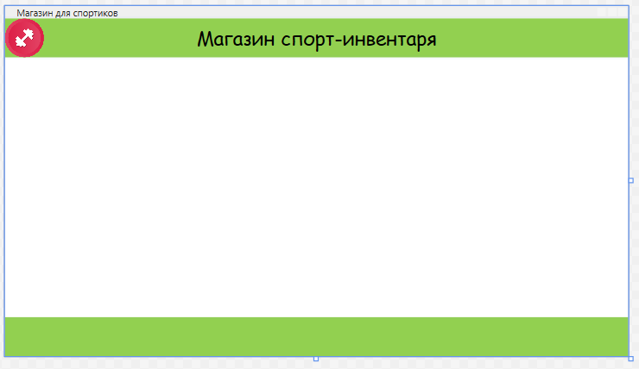

<Window x:Class="OOO_S_App.MainWindow"

xmlns="http://schemas.microsoft.com/winfx/2006/xaml/presentation"

xmlns:x="http://schemas.microsoft.com/winfx/2006/xaml"

xmlns:d="http://schemas.microsoft.com/expression/blend/2008"

xmlns:mc="http://schemas.openxmlformats.org/markup-compatibility/2006"

xmlns:local="clr-namespace:OOO_S_App"

mc:Ignorable="d"

Title="Магазин для спортиков" Height="450" Width="800" Style="{StaticResource window}" WindowState="Maximized">

<Grid>

<Grid.RowDefinitions>

<RowDefinition Height="50"/>

<RowDefinition Height="*"/>

<RowDefinition Height="50"/>

</Grid.RowDefinitions>

<Grid Background="#FF92D050">

<Image Source="/Resources/logo.png" HorizontalAlignment="Left" VerticalAlignment="Center"/>

<TextBlock Text="Магазин спорт-инвентаря" VerticalAlignment="Center" HorizontalAlignment="Center" FontSize="25"/>

</Grid>

<Grid Grid.Row="1">

<Frame Name="MainFrame" NavigationUIVisibility="Hidden"></Frame>

</Grid>

<Grid Grid.Row="2" Background="#FF92D050">

</Grid>

</Grid>

</Window>

MainWindow.xaml.cs

using OOO_S_App.Class;

using System;

using System.Collections.Generic;

using System.Linq;

using System.Text;

using System.Threading.Tasks;

using System.Windows;

using System.Windows.Controls;

using System.Windows.Data;

using System.Windows.Documents;

using System.Windows.Input;

using System.Windows.Media;

using System.Windows.Media.Imaging;

using System.Windows.Navigation;

using System.Windows.Shapes;

namespace OOO_S_App

{

/// <summary>

/// Логика взаимодействия для MainWindow.xaml

/// </summary>

public partial class MainWindow : Window

{

public MainWindow()

{

//накладка на окно страницу

InitializeComponent();

MainFrame.Navigate(new Pages.AvtorizPage());

Manager.MainFrame = MainFrame;

}

}

}

App.xaml

<Application x:Class="OOO_S_App.App"

xmlns="http://schemas.microsoft.com/winfx/2006/xaml/presentation"

xmlns:x="http://schemas.microsoft.com/winfx/2006/xaml"

xmlns:local="clr-namespace:OOO_S_App"

StartupUri="MainWindow.xaml">

<Application.Resources>

<!--стили!-->

<Style TargetType="Page" x:Key="base_page">

<Setter Property="FontFamily" Value="Comic Sans MS"></Setter>

</Style>

<Style TargetType="Window" x:Key="window">

<Setter Property="FontFamily" Value="Comic Sans MS"/>

</Style>

<Style x:Key="ButtonRadius" TargetType="Button">

<Setter Property="Background" Value="#FF349C3D"/>

<Setter Property="BorderBrush" Value="White"/>

<Style.Resources>

<Style TargetType="Border">

<Setter Property="CornerRadius" Value="5"></Setter>

</Style>

</Style.Resources>

</Style>

</Application.Resources>

</Application>

Resources

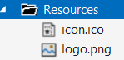

ZakazPage.xaml

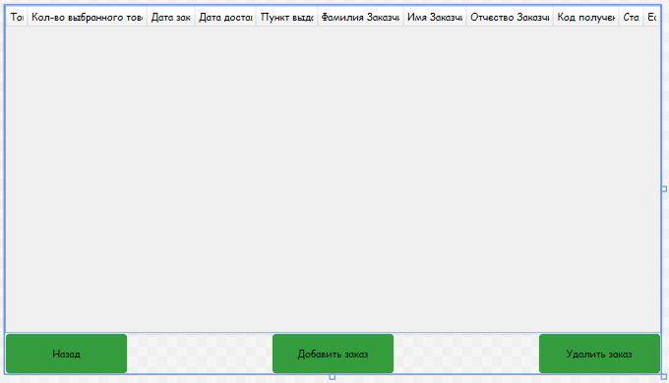

<Page x:Class="OOO_S_App.Pages.ZakazPage"

xmlns="http://schemas.microsoft.com/winfx/2006/xaml/presentation"

xmlns:x="http://schemas.microsoft.com/winfx/2006/xaml"

xmlns:mc="http://schemas.openxmlformats.org/markup-compatibility/2006"

xmlns:d="http://schemas.microsoft.com/expression/blend/2008"

xmlns:local="clr-namespace:OOO_S_App.Pages"

mc:Ignorable="d"

d:DesignHeight="450" d:DesignWidth="800"

Title="ZakazPage" Style="{StaticResource base_page}" IsVisibleChanged="Page_IsVisibleChanged">

<Grid>

<Grid.RowDefinitions>

<RowDefinition Height="*"/>

<RowDefinition Height="50"/>

</Grid.RowDefinitions>

<DataGrid x:Name="Zakaz" AutoGenerateColumns="False" IsReadOnly="True" RowHeight="30" SelectionMode="Single" LoadingRow="Zakaz_LoadingRow" SelectionChanged="Zakaz_SelectionChanged">

<DataGrid.Columns>

<DataGridTextColumn Binding="{Binding Z_Sostav}" Header="Товар" Width="auto"/>

<DataGridTextColumn Binding="{Binding Z_Kolich}" Header="Кол-во выбранного товара" Width="auto"/>

<DataGridTextColumn Binding="{Binding Z_Data_Zakaza}" Header="Дата заказа" Width="auto"/>

<DataGridTextColumn Binding="{Binding Z_Data_Dostav}" Header="Дата доставки" Width="auto"/>

<DataGridTextColumn Binding="{Binding Pynkt_vid.P_Ylica}" Header="Пункт выдачи" Width="auto"/>

<DataGridTextColumn Binding="{Binding Z_Famil}" Header="Фамилия Заказчика" Width="auto"/>

<DataGridTextColumn Binding="{Binding Z_Imya}" Header="Имя Заказчика" Width="auto"/>

<DataGridTextColumn Binding="{Binding Z_Otchestvo}" Header="Отчество Заказчика" Width="auto"/>

<DataGridTextColumn Binding="{Binding Z_Kod_Polych}" Header="Код получения" Width="auto"/>

<DataGridTextColumn Binding="{Binding Status.S_Name}" Header="Статус" Width="auto"/>

<DataGridTemplateColumn Width="*" Header="Edit">

<DataGridTemplateColumn.CellTemplate>

<DataTemplate>

<Button x:Name="BtnEdit" Style="{StaticResource ButtonRadius}" Content="*EDIT*" Click="BtnEdit_Click"/>

</DataTemplate>

</DataGridTemplateColumn.CellTemplate>

</DataGridTemplateColumn>

</DataGrid.Columns>

</DataGrid>

<Button x:Name="addzakaz" Content="Добавить заказ" Grid.Row="1" Style="{StaticResource ButtonRadius}" Width="150" Height="50" VerticalAlignment="Center" HorizontalAlignment="Center" Click="addzakaz_Click"/>

<Button x:Name="deletezakaz" Content="Удалить заказ" Grid.Row="1" Style="{StaticResource ButtonRadius}" Width="150" Height="50" VerticalAlignment="Center" HorizontalAlignment="Right" Click="deletezakaz_Click"/>

<Button x:Name="back" Content="Назад" Grid.Row="1" Style="{StaticResource ButtonRadius}" Width="150" Height="50" VerticalAlignment="Center" HorizontalAlignment="Left" Click="back_Click"/>

</Grid>

</Page>

ZakazPage.xaml.cs

using OOO_S_App.Base;

using System;

using System.Collections.Generic;

using System.Linq;

using System.Text;

using System.Threading.Tasks;

using System.Windows;

using System.Windows.Controls;

using System.Windows.Data;

using System.Windows.Documents;

using System.Windows.Input;

using System.Windows.Media;

using System.Windows.Media.Imaging;

using System.Windows.Navigation;

using System.Windows.Shapes;

namespace OOO_S_App.Pages

{

/// <summary>

/// Логика взаимодействия для ZakazPage.xaml

/// </summary>

public partial class ZakazPage : Page

{

public ZakazPage()

{

//работа с данными для вывода

InitializeComponent();

List<Zakaz> zak = TradeEntities.GetContext().Zakazs.OrderBy(p => p.Z_Data_Dostav).ToList();

Zakaz.ItemsSource = zak;

}

private void back_Click(object sender, RoutedEventArgs e)

{

NavigationService.GoBack();

}

private void addzakaz_Click(object sender, RoutedEventArgs e)

{

NavigationService.Navigate(new Pages.FarmZakazPage(null));

}

private void deletezakaz_Click(object sender, RoutedEventArgs e)

{

//кнопка удаление заказа

var _selectedzakaz = Zakaz.SelectedItems.Cast<Zakaz>().ToList();

MessageBoxResult messageBoxResult = MessageBox.Show($"Удалить {_selectedzakaz.Count()} записей???",

"Удаление", MessageBoxButton.OKCancel, MessageBoxImage.Question);

if (messageBoxResult == MessageBoxResult.OK)

{

try

{

Zakaz x = _selectedzakaz[0];

TradeEntities.GetContext().Zakazs.Remove(x);

TradeEntities.GetContext().SaveChanges();

MessageBox.Show("Записи удалены");

List<Zakaz> tours = TradeEntities.GetContext().Zakazs.OrderBy(p => p.Z_Data_Dostav).ToList();

Zakaz.ItemsSource = null;

Zakaz.ItemsSource = tours;

}

catch (Exception ex)

{

MessageBox.Show(ex.Message.ToString(), "Ошибка удаления", MessageBoxButton.OK, MessageBoxImage.Error);

}

}

}

private void Zakaz_LoadingRow(object sender, DataGridRowEventArgs e)

{

e.Row.Header = (e.Row.GetIndex() + 1).ToString();

}

private void Zakaz_SelectionChanged(object sender, SelectionChangedEventArgs e)

{

}

private void BtnEdit_Click(object sender, RoutedEventArgs e)

{

NavigationService.Navigate(new Pages.FarmZakazPage((sender as Button).DataContext as Zakaz));

}

private void Page_IsVisibleChanged(object sender, DependencyPropertyChangedEventArgs e)

{

//оператор случая служит для вывода данных из БД

List<Zakaz> zak = TradeEntities.GetContext().Zakazs.OrderBy(p => p.Z_Data_Dostav).ToList();

Zakaz.ItemsSource = zak;

}

}

}

ManagerPage.xaml

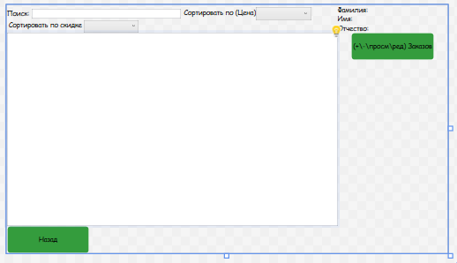

<Page x:Class="OOO_S_App.Pages.ManagerPage"

xmlns="http://schemas.microsoft.com/winfx/2006/xaml/presentation"

xmlns:x="http://schemas.microsoft.com/winfx/2006/xaml"

xmlns:mc="http://schemas.openxmlformats.org/markup-compatibility/2006"

xmlns:d="http://schemas.microsoft.com/expression/blend/2008"

xmlns:local="clr-namespace:OOO_S_App.Pages"

mc:Ignorable="d"

d:DesignHeight="450" d:DesignWidth="800"

Title="ManagerPage" Style="{StaticResource base_page}" IsVisibleChanged="Page_IsVisibleChanged">

<Grid>

<Grid.ColumnDefinitions>

<ColumnDefinition Width="*"/>

<ColumnDefinition Width="100"/>

<ColumnDefinition Width="100"/>

</Grid.ColumnDefinitions>

<Grid.RowDefinitions>

<RowDefinition Height="50"/>

<RowDefinition Height="*"/>

<RowDefinition Height="50"/>

</Grid.RowDefinitions>

<Grid>

<WrapPanel VerticalAlignment="Bottom" HorizontalAlignment="Left">

<StackPanel Orientation="Horizontal" VerticalAlignment="Center">

<TextBlock Text="Поиск:" />

<TextBox x:Name="TBP" Width="270" Margin="5,0,5,0" TextChanged="TBP_TextChanged"/>

</StackPanel>

<StackPanel Orientation="Horizontal">

<TextBlock Text="Сортировать по (Цена)"/>

<ComboBox Name="CBS" DisplayMemberPath="" Width="100" SelectionChanged="CBS_SelectionChanged">

<ComboBoxItem Content="По возрастанию"/>

<ComboBoxItem Content="По убыванию"/>

</ComboBox>

</StackPanel>

<StackPanel Orientation="Horizontal" VerticalAlignment="Center">

<TextBlock Text=" Сортировать по скидке "/>

<ComboBox Name="CBBEB" SelectionChanged="CBBEB_SelectionChanged" Width="100">

<ComboBoxItem Content="Все"></ComboBoxItem>

<ComboBoxItem Content="0-10%"></ComboBoxItem>

<ComboBoxItem Content="11-15%"></ComboBoxItem>

<ComboBoxItem Content="16+%"></ComboBoxItem>

</ComboBox>

</StackPanel>

</WrapPanel>

</Grid>

<Grid Grid.Row="1">

<Grid.RowDefinitions>

</Grid.RowDefinitions>

<ListView x:Name="LVTovar" Grid.Row="1" ScrollViewer.HorizontalScrollBarVisibility="Disabled">

<ListView.ItemsPanel >

<ItemsPanelTemplate>

<WrapPanel Orientation="Vertical" HorizontalAlignment="Center"/>

</ItemsPanelTemplate>

</ListView.ItemsPanel>

<ListView.ItemTemplate>

<DataTemplate>

<Grid Background="{Binding GetColor}">

<Grid.ColumnDefinitions>

<ColumnDefinition/>

<ColumnDefinition/>

<ColumnDefinition/>

</Grid.ColumnDefinitions>

<StackPanel Orientation="Horizontal" Height="auto" Width="auto">

<Image Width="90" HorizontalAlignment="Center" VerticalAlignment="Center" Source="{Binding Path=GetPhoto}"/>

<StackPanel Grid.Column="1" Margin="30 0 25 0" Width="250" HorizontalAlignment="Center" VerticalAlignment="Center">

<TextBlock FontWeight="Bold" Text="{Binding Path=T_Spisok_ID}"/>

<TextBlock Text="{Binding Path=T_Opis}"/>

<TextBlock Text="{Binding Path=Proizvod.P_Name}"/>

<TextBlock Text="{Binding Path=T_Stoimost, StringFormat={}{0} рублей}" TextDecorations="{Binding Path=GetTextDecotation}"/>

<TextBlock Text="{Binding ProductPriceWithDiscount}"/>

</StackPanel>

<StackPanel Grid.Column="2" Margin="0 0 0 0" VerticalAlignment="Center" HorizontalAlignment="Right">

<TextBlock Text="{Binding Path=T_Destv_Skidka, StringFormat={}{0} %}"/>

</StackPanel>

</StackPanel>

</Grid>

</DataTemplate>

</ListView.ItemTemplate>

</ListView>

</Grid>

<StackPanel Grid.Column="1" Orientation="Vertical" HorizontalAlignment="Left" VerticalAlignment="Top">

<TextBlock Text="Фамилия:"/>

<TextBlock Text="Имя:"/>

<TextBlock Text="Отчество:"/>

</StackPanel>

<StackPanel Grid.Column="2" Orientation="Vertical" Width="100" HorizontalAlignment="Center" VerticalAlignment="Top">

<TextBlock x:Name="TbFamil" Text="{Binding U_Familya}"/>

<TextBlock x:Name="TbImya" Text="{Binding U_Imya}"/>

<TextBlock x:Name="TbOtchestvo" Text="{Binding U_Otchestvo}"/>

</StackPanel>

<Button x:Name="back" Content="Назад" Grid.Row="2" Style="{StaticResource ButtonRadius}" Width="150" Height="50" VerticalAlignment="Center" HorizontalAlignment="Left" Click="back_Click"/>

<Button x:Name="zakaz" Content="(+\-\просм\ред) Заказов" HorizontalAlignment="Center" VerticalAlignment="Top" Click="zakaz_Click" Style="{StaticResource ButtonRadius}" Grid.ColumnSpan="2" Grid.Column="1" Width="150" Height="50" Grid.Row="1"/>

</Grid>

</Page>

GostPage.xaml

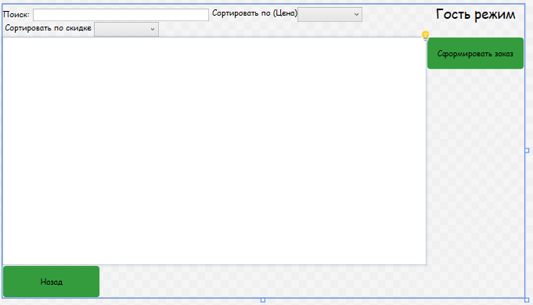

<Page x:Class="OOO_S_App.Pages.GostPage"

xmlns="http://schemas.microsoft.com/winfx/2006/xaml/presentation"

xmlns:x="http://schemas.microsoft.com/winfx/2006/xaml"

xmlns:mc="http://schemas.openxmlformats.org/markup-compatibility/2006"

xmlns:d="http://schemas.microsoft.com/expression/blend/2008"

xmlns:local="clr-namespace:OOO_S_App.Pages"

mc:Ignorable="d"

d:DesignHeight="450" d:DesignWidth="800"

Title="GostPage" Style="{StaticResource base_page}" IsVisibleChanged="Page_IsVisibleChanged">

<Grid>

<Grid.ColumnDefinitions>

<ColumnDefinition Width="*"/>

<ColumnDefinition Width="150"/>

</Grid.ColumnDefinitions>

<Grid.RowDefinitions>

<RowDefinition Height="50"/>

<RowDefinition Height="*"/>

<RowDefinition Height="50"/>

</Grid.RowDefinitions>

<StackPanel Grid.Column="1" Orientation="Vertical" HorizontalAlignment="Center" VerticalAlignment="Top">

<TextBlock Text="Гость режим" FontSize="20"/>

</StackPanel>

<Grid>

<WrapPanel VerticalAlignment="Bottom" HorizontalAlignment="Left">

<StackPanel Orientation="Horizontal" VerticalAlignment="Center">

<TextBlock Text="Поиск:" />

<TextBox x:Name="TBP" Width="270" Margin="5,0,5,0" TextChanged="TBP_TextChanged"/>

</StackPanel>

<StackPanel Orientation="Horizontal">

<TextBlock Text="Сортировать по (Цена)"/>

<ComboBox Name="CBS" Width="100" DisplayMemberPath="" SelectionChanged="CBS_SelectionChanged">

<ComboBoxItem Content="По возрастанию"/>

<ComboBoxItem Content="По убыванию"/>

</ComboBox>

</StackPanel>

<StackPanel Orientation="Horizontal" VerticalAlignment="Center">

<TextBlock Text=" Сортировать по скидке "/>

<ComboBox Name="CBBEB" SelectionChanged="CBBEB_SelectionChanged" Width="100">

<ComboBoxItem Content="Все"></ComboBoxItem>

<ComboBoxItem Content="0-10%"></ComboBoxItem>

<ComboBoxItem Content="11-15%"></ComboBoxItem>

<ComboBoxItem Content="16+%"></ComboBoxItem>

</ComboBox>

</StackPanel>

</WrapPanel>

</Grid>

<Grid Grid.Row="1">

<Grid.RowDefinitions>

</Grid.RowDefinitions>

<ListView x:Name="LVTovar" Grid.Row="1" ScrollViewer.HorizontalScrollBarVisibility="Disabled">

<ListView.ItemsPanel >

<ItemsPanelTemplate>

<WrapPanel Orientation="Vertical" HorizontalAlignment="Center"/>

</ItemsPanelTemplate>

</ListView.ItemsPanel>

<ListView.ItemTemplate>

<DataTemplate>

<Grid Background="{Binding GetColor}">

<Grid.ColumnDefinitions>

<ColumnDefinition/>

<ColumnDefinition/>

<ColumnDefinition/>

</Grid.ColumnDefinitions>

<StackPanel Orientation="Horizontal" Height="auto" Width="auto">

<Image Width="90" HorizontalAlignment="Center" VerticalAlignment="Center" Source="{Binding Path=GetPhoto}"/>

<StackPanel Grid.Column="1" Margin="30 0 25 0" Width="250" HorizontalAlignment="Center" VerticalAlignment="Center">

<TextBlock FontWeight="Bold" Text="{Binding Path=T_Spisok_ID}"/>

<TextBlock Text="{Binding Path=T_Opis}"/>

<TextBlock Text="{Binding Path=Proizvod.P_Name}"/>

<TextBlock Text="{Binding Path=T_Stoimost, StringFormat={}{0} рублей}" TextDecorations="{Binding Path=GetTextDecotation}"/>

<TextBlock Text="{Binding ProductPriceWithDiscount}"/>

</StackPanel>

<StackPanel Grid.Column="2" Margin="0 0 0 0" VerticalAlignment="Center" HorizontalAlignment="Right">

<TextBlock Text="{Binding Path=T_Destv_Skidka, StringFormat={}{0} %}"/>

</StackPanel>

</StackPanel>

</Grid>

</DataTemplate>

</ListView.ItemTemplate>

</ListView>

</Grid>

<Button x:Name="farm_zakaz" Content="Сформировать заказ" HorizontalAlignment="Center" VerticalAlignment="Top" Click="farm_zakaz_Click" Style="{StaticResource ButtonRadius}" Grid.Column="1" Width="150" Height="50" Grid.Row="1"/>

<Button x:Name="back" Content="Назад" Grid.Row="2" Style="{StaticResource ButtonRadius}" Width="150" Height="50" VerticalAlignment="Center" HorizontalAlignment="Left" Click="back_Click"/>

</Grid>

</Page>

GostPage.xaml.cs

using OOO_S_App.Base;

using OOO_S_App.Class;

using System;

using System.Collections.Generic;

using System.Linq;

using System.Text;

using System.Threading.Tasks;

using System.Windows;

using System.Windows.Controls;

using System.Windows.Data;

using System.Windows.Documents;

using System.Windows.Input;

using System.Windows.Media;

using System.Windows.Media.Imaging;

using System.Windows.Navigation;

using System.Windows.Shapes;

namespace OOO_S_App.Pages

{

/// <summary>

/// Логика взаимодействия для GostPage.xaml

/// </summary>

public partial class GostPage : Page

{

public GostPage()

{

InitializeComponent();

}

private void back_Click(object sender, RoutedEventArgs e)

{

NavigationService.Navigate(new Pages.AvtorizPage());

}

private void farm_zakaz_Click(object sender, RoutedEventArgs e)

{

NavigationService.Navigate(new Pages.FarmZakazPage(null));

}

private void Page_IsVisibleChanged(object sender, DependencyPropertyChangedEventArgs e)

{

if (Visibility == Visibility.Visible)

{

TradeEntities.GetContext().ChangeTracker.Entries().ToList().ForEach(p => p.Reload());

LVTovar.ItemsSource = TradeEntities.GetContext().Tovars.OrderBy(p => p.T_Artikyl_ID).ToList();

}

}

private void TBP_TextChanged(object sender, TextChangedEventArgs e)

{

UpdateData();

}

private void CBS_SelectionChanged(object sender, SelectionChangedEventArgs e)

{

UpdateData();

}

private void UpdateData()

{

//метод для вписание нужных данных в БД

var currentProduct = TradeEntities.GetContext().Tovars.OrderBy(p => p.T_Spisok_ID).ToList();

currentProduct = currentProduct.Where(p => p.T_Spisok_ID.ToLower().Contains(TBP.Text.ToLower())).ToList();

if (CBS.SelectedIndex >= 0)

{

if (CBS.SelectedIndex == 0)

{

currentProduct = currentProduct.OrderBy(p => p.T_Stoimost).ToList();

}

if (CBS.SelectedIndex == 1)

{

currentProduct = currentProduct.OrderByDescending(p => p.T_Stoimost).ToList();

}

}

LVTovar.ItemsSource = currentProduct;

}

private void CBBEB_SelectionChanged(object sender, SelectionChangedEventArgs e)

{

UpdateData1();

}

private void UpdateData1()

{

//метод для сортировки данных по размеру скидки

var currentProduct = TradeEntities.GetContext().Tovars.OrderBy(p => p.T_Spisok_ID).ToList();

currentProduct = currentProduct.Where(p => p.T_Spisok_ID.ToLower().Contains(TBP.Text.ToLower())).ToList();

if (CBS.SelectedIndex >= 0)

{

if (CBS.SelectedIndex == 0)

{

currentProduct = currentProduct.OrderBy(p => p.T_Stoimost).ToList();

}

if (CBS.SelectedIndex == 1)

{

currentProduct = currentProduct.OrderByDescending(p => p.T_Stoimost).ToList();

}

}

if (CBBEB.SelectedIndex > 0)

{

int a = 0;

int b = 0;

switch (CBBEB.SelectedIndex)

{

case 1:

a = 0;

b = 10;

break;

case 2:

a = 11;

b = 15;

break;

case 3:

a = 16;

b = 100;

break;

}

currentProduct = currentProduct.Where(p => p.T_Destv_Skidka > a && p.T_Destv_Skidka <= b).ToList();

}

LVTovar.ItemsSource = currentProduct;

}

}

}

FarmZakazPage.xaml

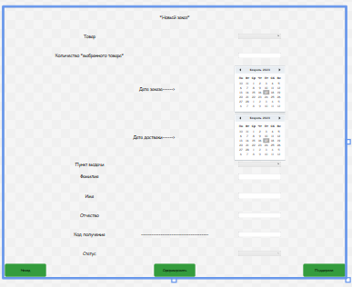

<Page x:Class="OOO_S_App.Pages.FarmZakazPage"

xmlns="http://schemas.microsoft.com/winfx/2006/xaml/presentation"

xmlns:x="http://schemas.microsoft.com/winfx/2006/xaml"

xmlns:mc="http://schemas.openxmlformats.org/markup-compatibility/2006"

xmlns:d="http://schemas.microsoft.com/expression/blend/2008"

xmlns:local="clr-namespace:OOO_S_App.Pages"

mc:Ignorable="d"

d:DesignHeight="950" d:DesignWidth="1200"

Title="FarmZakazPage" Style="{StaticResource base_page}">

<Grid>

<Grid.ColumnDefinitions>

<ColumnDefinition Width="*"/>

<ColumnDefinition Width="*"/>

</Grid.ColumnDefinitions>

<Grid.RowDefinitions>

<RowDefinition Height="*"/>

<RowDefinition Height="*"/>

<RowDefinition Height="*"/>

<RowDefinition Height="170"/>

<RowDefinition Height="auto"/>

<RowDefinition Height="auto"/>

<RowDefinition Height="*"/>

<RowDefinition Height="*"/>

<RowDefinition Height="*"/>

<RowDefinition Height="*"/>

<RowDefinition Height="*"/>

<RowDefinition Height="50"/>

</Grid.RowDefinitions>

<Button x:Name="back" Content="Назад" Grid.Row="11" Style="{StaticResource ButtonRadius}" Width="150" Height="50" VerticalAlignment="Center" HorizontalAlignment="Left" Click="back_Click"/>

<Button x:Name="new" Content="Сформировать" Grid.Row="11" Grid.ColumnSpan="2" Style="{StaticResource ButtonRadius}" Width="150" Height="50" VerticalAlignment="Center" HorizontalAlignment="Center" Click="new_Click"/>

<Button x:Name="TP" Content="Поддержка" Grid.Row="11" Grid.Column="1" Style="{StaticResource ButtonRadius}" Width="150" Height="50" VerticalAlignment="Center" HorizontalAlignment="Right" Click="TP_Click"/>

<TextBlock Text="Товар" VerticalAlignment="Center" Grid.Row="1" HorizontalAlignment="Center" FontSize="15"/>

<TextBlock Text="Количество *выбранного товара*" Grid.Row="2" VerticalAlignment="Center" HorizontalAlignment="Center" FontSize="15"/>

<TextBlock Text="Дата заказа------>" Grid.Row="3" VerticalAlignment="Center" HorizontalAlignment="Right" FontSize="15"/>

<TextBlock Text="Дата достваки------>" Grid.Row="4" VerticalAlignment="Center" HorizontalAlignment="Right" FontSize="15"/>

<TextBlock Text="Пункт выдачи" Grid.Row="5" VerticalAlignment="Center" HorizontalAlignment="Center" FontSize="15"/>

<TextBlock Text="Фамилия" Grid.Row="6" VerticalAlignment="Center" HorizontalAlignment="Center" FontSize="15"/>

<TextBlock Text="Имя" Grid.Row="7" VerticalAlignment="Center" HorizontalAlignment="Center" FontSize="15"/>

<TextBlock Text="Отчество" Grid.Row="8" VerticalAlignment="Center" HorizontalAlignment="Center" FontSize="15"/>

<TextBlock Text="--------------------------------------" Grid.ColumnSpan="2" Grid.Row="9" VerticalAlignment="Center" HorizontalAlignment="Center" FontSize="15"/>

<TextBlock Text="*Новый заказ*" VerticalAlignment="Center" Grid.ColumnSpan="2" HorizontalAlignment="Center" FontSize="15"/>

<Calendar x:Name="calend" Grid.Row="3" Grid.Column="1" FirstDayOfWeek="Monday" Visibility="Visible" HorizontalAlignment="Center" SelectedDate="{Binding Z_Data_Zakaza}" Width="auto" Height="auto"/>

<Calendar x:Name="calend1" Grid.Row="4" Grid.Column="1" FirstDayOfWeek="Monday" SelectedDate="{Binding Z_Data_Dostav}" HorizontalAlignment="Center" VerticalAlignment="Center" Width="auto" Height="auto"/>

<ComboBox x:Name="CBTovar" Grid.Row="1" Grid.Column="1" SelectedItem="{Binding Tovar}" DisplayMemberPath="T_Artikyl_ID" Width="150" Height="20"/>

<TextBox x:Name="TBKol" Grid.Column="1" Grid.Row="2" Text="{Binding Z_Kolich}" Width="150" Height="20" HorizontalAlignment="Center" VerticalAlignment="Center"/>

<ComboBox x:Name="CBPV" Grid.Row="5" Grid.Column="1" SelectedItem="{Binding Pynkt_vid}" DisplayMemberPath="P_Ylica" Width="150" Height="20" Margin="225,1,225,0" VerticalAlignment="Top"/>

<TextBox x:Name="TBFam" Grid.Column="1" Grid.Row="6" Text="{Binding Z_Famil}" Width="150" Height="20" HorizontalAlignment="Center" VerticalAlignment="Center"/>

<TextBox x:Name="TBIm" Grid.Column="1" Grid.Row="7" Text="{Binding Z_Imya}" Width="150" Height="20" HorizontalAlignment="Center" VerticalAlignment="Center"/>

<TextBox x:Name="TBOtch" Grid.Column="1" Grid.Row="8" Text="{Binding Z_Otchestvo}" Width="150" Height="20" HorizontalAlignment="Center" VerticalAlignment="Center"/>

<TextBlock Text="Код получения" Grid.Row="9" FontSize="15" VerticalAlignment="Center" HorizontalAlignment="Center"/>

<TextBlock Text="Статус" Grid.Row="10" FontSize="15" VerticalAlignment="Center" HorizontalAlignment="Center"/>

<TextBox x:Name="TBKP" Grid.Column="1" Visibility="Visible" Text="{Binding Z_Kod_Polych}" Grid.Row="9" Width="150" Height="20" HorizontalAlignment="Center" VerticalAlignment="Center" />

<ComboBox x:Name="TBStatus" Visibility="Visible" Grid.Column="1" Grid.Row="10" SelectedItem="{Binding Status}" DisplayMemberPath="S_Name" Width="150" Height="20" HorizontalAlignment="Center" VerticalAlignment="Center" />

</Grid>

</Page>

FarmZakazPage.xaml.cs

using OOO_S_App.Base;

using System;

using System.Collections.Generic;

using System.Linq;

using System.Text;

using System.Threading.Tasks;

using System.Windows;

using System.Windows.Controls;

using System.Windows.Data;

using System.Windows.Documents;

using System.Windows.Input;

using System.Windows.Media;

using System.Windows.Media.Imaging;

using System.Windows.Navigation;

using System.Windows.Shapes;

namespace OOO_S_App.Pages

{

/// <summary>

/// Логика взаимодействия для FarmZakazPage.xaml

/// </summary>

public partial class FarmZakazPage : Page

{

public static Zakaz _zak { get; set; }

public FarmZakazPage(Zakaz selectedep)

{

//работа с данными в БД для вывода

InitializeComponent();

_zak = selectedep ?? new Zakaz();

DataContext = _zak;

CBTovar.ItemsSource = TradeEntities.GetContext().Tovars.ToList();

CBPV.ItemsSource = TradeEntities.GetContext().Pynkt_vid.ToList();

TBStatus.ItemsSource= TradeEntities.GetContext().Status.ToList();

}

private void back_Click(object sender, RoutedEventArgs e)

{

//кнопка назад

NavigationService.GoBack();

}

private void new_Click(object sender, RoutedEventArgs e)

{

//кнопка для сохранения уже сформированного заказа

try

{

_zak.Z_Pynkt_vid_ID = (CBPV.SelectedItem as Pynkt_vid).Pynkt_vid_ID;

_zak.Z_Sostav = (CBTovar.SelectedItem as Tovar).T_Artikyl_ID;

_zak.Z_Status_ID = (TBStatus.SelectedItem as Status).Status_ID;

if (_zak.Zakaz_ID == 0)

{

TradeEntities.GetContext().Zakazs.Add(_zak);

}

TradeEntities.GetContext().SaveChanges();

MessageBox.Show("Вы оформили заказ!");

NavigationService.GoBack();

}

catch (Exception ex)

{

MessageBox.Show(ex.InnerException.Message);

}

}

private void TP_Click(object sender, RoutedEventArgs e)

{

//кнопка для вывода комментария

MessageBox.Show("Тел: 89966064526");

}

}

}

ClientPage.xaml

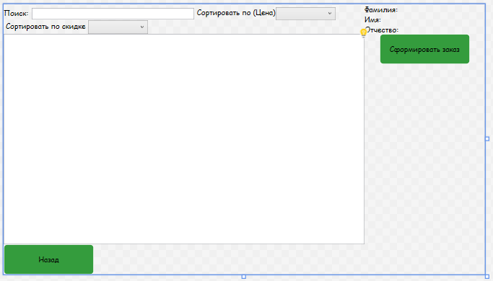

<Page x:Class="OOO_S_App.Pages.ClientPage"

xmlns="http://schemas.microsoft.com/winfx/2006/xaml/presentation"

xmlns:x="http://schemas.microsoft.com/winfx/2006/xaml"

xmlns:mc="http://schemas.openxmlformats.org/markup-compatibility/2006"

xmlns:d="http://schemas.microsoft.com/expression/blend/2008"

xmlns:local="clr-namespace:OOO_S_App.Pages"

mc:Ignorable="d"

d:DesignHeight="450" d:DesignWidth="800"

Title="ClientPage" Style="{StaticResource base_page}" IsVisibleChanged="Page_IsVisibleChanged">

<Grid>

<Grid.ColumnDefinitions>

<ColumnDefinition Width="*"/>

<ColumnDefinition Width="100"/>

<ColumnDefinition Width="100"/>

</Grid.ColumnDefinitions>

<Grid.RowDefinitions>

<RowDefinition Height="50"/>

<RowDefinition Height="*"/>

<RowDefinition Height="50"/>

</Grid.RowDefinitions>

<Grid>

<WrapPanel VerticalAlignment="Bottom" HorizontalAlignment="Left">

<StackPanel Orientation="Horizontal" VerticalAlignment="Center">

<TextBlock Text="Поиск:" />

<TextBox x:Name="TBP" Width="270" Margin="5,0,5,0" TextChanged="TBP_TextChanged"/>

</StackPanel>

<StackPanel Orientation="Horizontal">

<TextBlock Text="Сортировать по (Цена)"/>

<ComboBox Name="CBS" DisplayMemberPath="" Width="100" SelectionChanged="CBS_SelectionChanged">

<ComboBoxItem Content="По возрастанию"/>

<ComboBoxItem Content="По убыванию"/>

</ComboBox>

</StackPanel>

<StackPanel Orientation="Horizontal" VerticalAlignment="Center">

<TextBlock Text=" Сортировать по скидке "/>

<ComboBox Name="CBBEB" SelectionChanged="CBBEB_SelectionChanged" Width="100">

<ComboBoxItem Content="Все"></ComboBoxItem>

<ComboBoxItem Content="0-10%"></ComboBoxItem>

<ComboBoxItem Content="11-15%"></ComboBoxItem>

<ComboBoxItem Content="16+%"></ComboBoxItem>

</ComboBox>

</StackPanel>

</WrapPanel>

</Grid>

<Grid Grid.Row="1">

<Grid.RowDefinitions>

</Grid.RowDefinitions>

<ListView x:Name="LVTovar" Grid.Row="1" ScrollViewer.HorizontalScrollBarVisibility="Disabled">

<ListView.ItemsPanel >

<ItemsPanelTemplate>

<WrapPanel Orientation="Vertical" HorizontalAlignment="Center"/>

</ItemsPanelTemplate>

</ListView.ItemsPanel>

<ListView.ItemTemplate>

<DataTemplate>

<Grid Background="{Binding GetColor}">

<Grid.ColumnDefinitions>

<ColumnDefinition/>

<ColumnDefinition/>

<ColumnDefinition/>

</Grid.ColumnDefinitions>

<StackPanel Orientation="Horizontal" Height="auto" Width="auto">

<Image Width="90" HorizontalAlignment="Center" VerticalAlignment="Center" Source="{Binding Path=GetPhoto}"/>

<StackPanel Grid.Column="1" Margin="30 0 25 0" Width="250" HorizontalAlignment="Center" VerticalAlignment="Center">

<TextBlock FontWeight="Bold" Text="{Binding Path=T_Spisok_ID}"/>

<TextBlock Text="{Binding Path=T_Opis}"/>

<TextBlock Text="{Binding Path=Proizvod.P_Name}"/>

<TextBlock Text="{Binding Path=T_Stoimost, StringFormat={}{0} рублей}" TextDecorations="{Binding Path=GetTextDecotation}"/>

<TextBlock Text="{Binding ProductPriceWithDiscount}"/>

</StackPanel>

<StackPanel Grid.Column="2" Margin="0 0 0 0" VerticalAlignment="Center" HorizontalAlignment="Right">

<TextBlock Text="{Binding Path=T_Destv_Skidka, StringFormat={}{0} %}"/>

</StackPanel>

</StackPanel>

</Grid>

</DataTemplate>

</ListView.ItemTemplate>

</ListView>

</Grid>

<StackPanel Grid.Column="1" Orientation="Vertical" HorizontalAlignment="Left" VerticalAlignment="Top">

<TextBlock Text="Фамилия:"/>

<TextBlock Text="Имя:"/>

<TextBlock Text="Отчество:"/>

</StackPanel>

<StackPanel Grid.Column="2" Orientation="Vertical" Width="100" HorizontalAlignment="Center" VerticalAlignment="Top">

<TextBlock x:Name="TbFamil" Text="{Binding U_Familya}"/>

<TextBlock x:Name="TbImya" Text="{Binding U_Imya}"/>

<TextBlock x:Name="TbOtchestvo" Text="{Binding U_Otchestvo}"/>

</StackPanel>

<Button x:Name="farm_zakaz" Content="Сформировать заказ" HorizontalAlignment="Center" VerticalAlignment="Top" Click="farm_zakaz_Click" Style="{StaticResource ButtonRadius}" Grid.ColumnSpan="2" Grid.Column="1" Width="150" Height="50" Grid.Row="1"/>

<Button x:Name="back" Content="Назад" Grid.Row="2" Style="{StaticResource ButtonRadius}" Width="150" Height="50" VerticalAlignment="Center" HorizontalAlignment="Left" Click="back_Click"/>

</Grid>

</Page>

ClientPage.xaml.cs

using OOO_S_App.Base;

using OOO_S_App.Class;

using System;

using System.Collections.Generic;

using System.Linq;

using System.Text;

using System.Threading.Tasks;

using System.Windows;

using System.Windows.Controls;

using System.Windows.Data;

using System.Windows.Documents;

using System.Windows.Input;

using System.Windows.Media;

using System.Windows.Media.Imaging;

using System.Windows.Navigation;

using System.Windows.Shapes;

namespace OOO_S_App.Pages

{

/// <summary>

/// Логика взаимодействия для ClientPage.xaml

/// </summary>

public partial class ClientPage : Page

{

public ClientPage()

{

//работа для выбора и вывода данных

InitializeComponent();

DataContext = TradeEntities.GetContext().Users.ToList();

List<User> users = TradeEntities.GetContext().Users.ToList();

TbFamil.Text = Auth.U_Familya;

TbImya.Text = Auth.U_Imya;

TbOtchestvo.Text = Auth.U_Otchestvo;

}

private void back_Click(object sender, RoutedEventArgs e)

{

//кнопка с ссылкой на страницу авторизации

NavigationService.Navigate(new Pages.AvtorizPage());

}

private void Page_IsVisibleChanged(object sender, DependencyPropertyChangedEventArgs e)

{

//проверка случая для вывода данных

if (Visibility == Visibility.Visible)

{

TradeEntities.GetContext().ChangeTracker.Entries().ToList().ForEach(p => p.Reload());

LVTovar.ItemsSource = TradeEntities.GetContext().Tovars.OrderBy(p => p.T_Artikyl_ID).ToList();

}

}

private void farm_zakaz_Click(object sender, RoutedEventArgs e)

{

//кнопка с ссылкой на формирование заказов

NavigationService.Navigate(new Pages.FarmZakazPage(null));

}

private void TBP_TextChanged(object sender, TextChangedEventArgs e)

{

UpdateData();

}

private void CBS_SelectionChanged(object sender, SelectionChangedEventArgs e)

{

UpdateData();

}

private void UpdateData()

{

//метод для вписание нужных данных в БД

var currentProduct = TradeEntities.GetContext().Tovars.OrderBy(p => p.T_Spisok_ID).ToList();

currentProduct = currentProduct.Where(p => p.T_Spisok_ID.ToLower().Contains(TBP.Text.ToLower())).ToList();

if (CBS.SelectedIndex >= 0)

{

if (CBS.SelectedIndex == 0)

{

currentProduct = currentProduct.OrderBy(p => p.T_Stoimost).ToList();

}

if (CBS.SelectedIndex == 1)

{

currentProduct = currentProduct.OrderByDescending(p => p.T_Stoimost).ToList();

}

}

LVTovar.ItemsSource = currentProduct;

}

private void CBBEB_SelectionChanged(object sender, SelectionChangedEventArgs e)

{

UpdateData1();

}

private void UpdateData1()

{

//метод который сортирует данные выводенные из БД в проект по скидке

var currentProduct = TradeEntities.GetContext().Tovars.OrderBy(p => p.T_Spisok_ID).ToList();

currentProduct = currentProduct.Where(p => p.T_Spisok_ID.ToLower().Contains(TBP.Text.ToLower())).ToList();

if (CBS.SelectedIndex >= 0)

{

if (CBS.SelectedIndex == 0)

{

currentProduct = currentProduct.OrderBy(p => p.T_Stoimost).ToList();

}

if (CBS.SelectedIndex == 1)

{

currentProduct = currentProduct.OrderByDescending(p => p.T_Stoimost).ToList();

}

}

if (CBBEB.SelectedIndex > 0)

{

int a = 0;

int b = 0;

switch (CBBEB.SelectedIndex)

{

case 1:

a = 0;

b = 10;

break;

case 2:

a = 11;

b = 15;

break;

case 3:

a = 16;

b = 100;

break;

}

currentProduct = currentProduct.Where(p => p.T_Destv_Skidka > a && p.T_Destv_Skidka <= b).ToList();

}

LVTovar.ItemsSource = currentProduct;

}

}

}

CaptchaPage.xaml

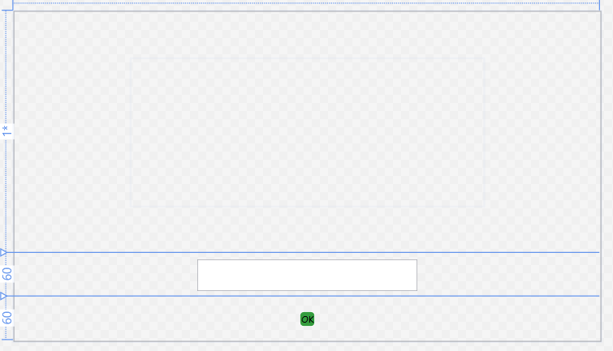

<Page x:Class="OOO_S_App.Pages.CaptchaPage"

xmlns="http://schemas.microsoft.com/winfx/2006/xaml/presentation"

xmlns:x="http://schemas.microsoft.com/winfx/2006/xaml"

xmlns:mc="http://schemas.openxmlformats.org/markup-compatibility/2006"

xmlns:d="http://schemas.microsoft.com/expression/blend/2008"

xmlns:local="clr-namespace:OOO_S_App.Pages"

mc:Ignorable="d"

d:DesignHeight="450" d:DesignWidth="800"

Title="CaptchaPage" Style="{StaticResource base_page}">

<Grid>

<Grid.RowDefinitions>

<RowDefinition Height="*"/>

<RowDefinition Height="60"/>

<RowDefinition Height="60"/>

</Grid.RowDefinitions>

<Image Name="CaptchaImage" Source="{Binding CaptchaPath}" Width="480" Height="200" />

<TextBox Name="CaptchaTb" Grid.Row="1" VerticalAlignment="Center" FontSize="30" Width="300"/>

<Button Name="CheckCaptcha" Click="CheckCaptcha_Click" Content="OK" Grid.Row="2" Style="{StaticResource ButtonRadius}" HorizontalAlignment="Center" VerticalAlignment="Center"/>

</Grid>

</Page>

CaptchaPage.xaml.cs

using OOO_S_App.Class;

using System;

using System.Collections.Generic;

using System.IO;

using System.Linq;

using System.Text;

using System.Threading.Tasks;

using System.Windows;

using System.Windows.Controls;

using System.Windows.Data;

using System.Windows.Documents;

using System.Windows.Input;

using System.Windows.Media;

using System.Windows.Media.Imaging;

using System.Windows.Navigation;

using System.Windows.Shapes;

namespace OOO_S_App.Pages

{

/// <summary>

/// Логика взаимодействия для CaptchaPage.xaml

/// </summary>

public partial class CaptchaPage : Page

{

//выбор и взятие класса который отвечает за КАПТЧА

string _correctCaptcha { get; set; }

public bool _isCorrect { get; set; } = false;

public CaptchaPage()

{

InitializeComponent();

_correctCaptcha = Captcha.CreateCaptcha();

CaptchaImage.Source = new BitmapImage(new Uri($@"{Directory.GetCurrentDirectory()}\Image\{_correctCaptcha}.png"));

}

private void CheckCaptcha_Click(object sender, RoutedEventArgs e)

{

//проверка и условие КАПТЧА

if (_correctCaptcha != CaptchaTb.Text)

{

MessageBox.Show("Каптча введена не верно");

NavigationService.Navigate(new Pages.CaptchaPage());

}

_isCorrect = true;

if (_correctCaptcha == CaptchaTb.Text)

{

NavigationService.Navigate(new Pages.AvtorizPage());

}

}

}

}

AvtorizPage.xaml

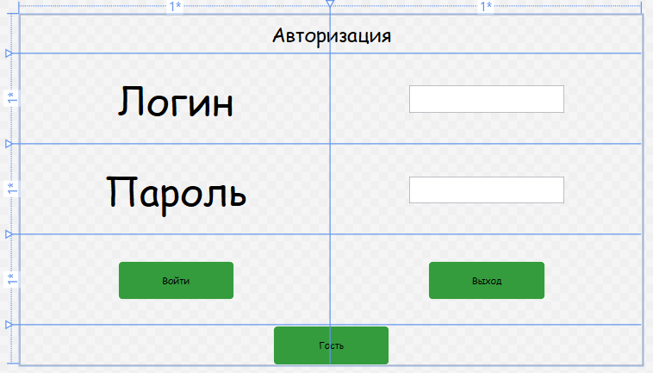

<Page x:Class="OOO_S_App.Pages.AvtorizPage"

xmlns="http://schemas.microsoft.com/winfx/2006/xaml/presentation"

xmlns:x="http://schemas.microsoft.com/winfx/2006/xaml"

xmlns:mc="http://schemas.openxmlformats.org/markup-compatibility/2006"

xmlns:d="http://schemas.microsoft.com/expression/blend/2008"

xmlns:local="clr-namespace:OOO_S_App.Pages"

mc:Ignorable="d"

d:DesignHeight="450" d:DesignWidth="800"

Title="AvtorizPage" Style="{StaticResource base_page}">

<Grid>

<Grid.ColumnDefinitions>

<ColumnDefinition Width="*"/>

<ColumnDefinition Width="*"/>

</Grid.ColumnDefinitions>

<Grid.RowDefinitions>

<RowDefinition Height="50"/>

<RowDefinition Height="*"/>

<RowDefinition Height="*"/>

<RowDefinition Height="*"/>

<RowDefinition Height="50"/>

</Grid.RowDefinitions>

<TextBlock Text="Авторизация" FontSize="25" Grid.ColumnSpan="2" VerticalAlignment="Center" HorizontalAlignment="Center"/>

<TextBlock Text="Логин" Grid.Row="1" FontSize="50" VerticalAlignment="Center" HorizontalAlignment="Center"/>

<TextBlock Text="Пароль" Grid.Row="2" FontSize="50" VerticalAlignment="Center" HorizontalAlignment="Center"/>

<TextBox x:Name="TB" Grid.Column="1" Grid.Row="1" Width="200" Height="35" VerticalAlignment="Center" HorizontalAlignment="Center"/>

<PasswordBox x:Name="PB" Grid.Row="2" Grid.Column="1" Width="200" Height="35" HorizontalAlignment="Center" VerticalAlignment="Center"/>

<Button x:Name="gost" Content="Гость" ToolTip="*Войти как гость*" Style="{StaticResource ButtonRadius}" Width="150" Grid.Row="4" Grid.ColumnSpan="2" Height="50" Click="gost_Click"/>

<Button x:Name="vhod" Content="Войти" HorizontalAlignment="Center" VerticalAlignment="Center" Click="vhod_Click" Style="{StaticResource ButtonRadius}" Width="150" Height="50" Grid.Row="3"/>

<Button x:Name="omena" Content="Выход" HorizontalAlignment="Center" VerticalAlignment="Center" Click="omena_Click" Style="{StaticResource ButtonRadius}" Width="150" Height="50" Grid.Row="3" Grid.Column="1"/>

</Grid>

</Page>

AvtorizPage.xaml.cs

using OOO_S_App.Base;

using OOO_S_App.Class;

using System;

using System.Collections.Generic;

using System.Linq;

using System.Text;

using System.Threading.Tasks;

using System.Windows;

using System.Windows.Controls;

using System.Windows.Data;

using System.Windows.Documents;

using System.Windows.Input;

using System.Windows.Media;

using System.Windows.Media.Imaging;

using System.Windows.Navigation;

using System.Windows.Shapes;

namespace OOO_S_App.Pages

{

/// <summary>

/// Логика взаимодействия для AvtorizPage.xaml

/// </summary>

public partial class AvtorizPage : Page

{

short _attempts;

public AvtorizPage()

{

InitializeComponent();

_attempts = 0;

}

private void gost_Click(object sender, RoutedEventArgs e)

{

//кнопа с ссылкой и сообщение для пользователя

MessageBox.Show("*Режим ГОСТЬ включен*");

NavigationService.Navigate(new Pages.GostPage());

}

private void vhod_Click(object sender, RoutedEventArgs e)

{

//авторизация для включенных юзеров описанных в БД

try

{

_attempts++;

User user = TradeEntities.GetContext().Users.FirstOrDefault(u => u.U_Login == TB.Text && u.U_Pass == PB.Password);

if (user != null)

{

if (user.U_Role_ID == 1)

{

Auth.U_Familya = user.U_Familya;

Auth.U_Imya = user.U_Imya;

Auth.U_Otchestvo = user.U_Otchestvo;

MessageBox.Show("*Вы вошли в систему под ролью - Клиент*");

NavigationService.Navigate(new Pages.ClientPage());

}

else if (user.U_Role_ID == 2)

{

Auth.U_Familya = user.U_Familya;

Auth.U_Imya = user.U_Imya;

Auth.U_Otchestvo = user.U_Otchestvo;

MessageBox.Show("*Вы вошли в систему под ролью - Админ*");

NavigationService.Navigate(new Pages.AdminPage());

}

else if (user.U_Role_ID == 3)

{

Auth.U_Familya = user.U_Familya;

Auth.U_Imya = user.U_Imya;

Auth.U_Otchestvo = user.U_Otchestvo;

MessageBox.Show("*Вы вошли в систему под ролью - Менеджер*");

NavigationService.Navigate(new Pages.ManagerPage());

}

}

else

{

if (_attempts < 2)

{

MessageBox.Show("*Неверный логин или пароль*");

}

else

{

NavigationService.Navigate(new Pages.CaptchaPage());

}

}

}

catch (Exception ex)

{

MessageBox.Show(ex.Message.ToString());

}

}

private void omena_Click(object sender, RoutedEventArgs e)

{

//кнопка для выхода из приложения

App.Current.Shutdown();

}

}

}

AdminPage.xaml

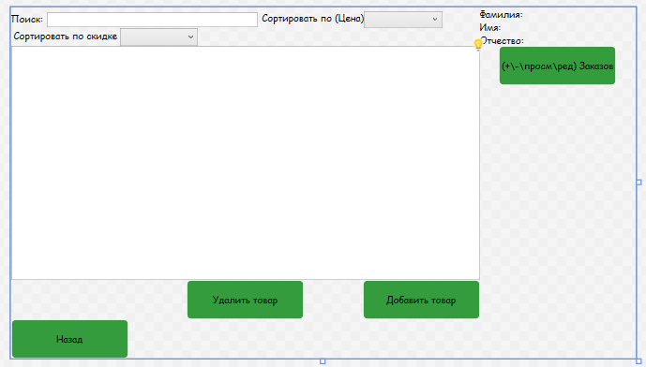

<Page x:Class="OOO_S_App.Pages.AdminPage"

xmlns="http://schemas.microsoft.com/winfx/2006/xaml/presentation"

xmlns:x="http://schemas.microsoft.com/winfx/2006/xaml"

xmlns:mc="http://schemas.openxmlformats.org/markup-compatibility/2006"

xmlns:d="http://schemas.microsoft.com/expression/blend/2008"

xmlns:local="clr-namespace:OOO_S_App.Pages"

mc:Ignorable="d"

d:DesignHeight="450" d:DesignWidth="800"

Title="AdminPage" Style="{StaticResource base_page}" IsVisibleChanged="Page_IsVisibleChanged">

<Grid>

<Grid.ColumnDefinitions>

<ColumnDefinition Width="*"/>

<ColumnDefinition Width="100"/>

<ColumnDefinition Width="100"/>

</Grid.ColumnDefinitions>

<Grid.RowDefinitions>

<RowDefinition Height="50"/>

<RowDefinition Height="*"/>

<RowDefinition Height="50"/>

<RowDefinition Height="50"/>

</Grid.RowDefinitions>

<Grid Grid.Row="1">

<Grid.RowDefinitions>

</Grid.RowDefinitions>

<ListView x:Name="LVTovar" Grid.Row="1" ScrollViewer.HorizontalScrollBarVisibility="Disabled">

<ListView.ItemsPanel >

<ItemsPanelTemplate>

<WrapPanel Orientation="Vertical" HorizontalAlignment="Center"/>

</ItemsPanelTemplate>

</ListView.ItemsPanel>

<ListView.ItemTemplate>

<DataTemplate>

<Grid Background="{Binding GetColor}">

<Grid.ColumnDefinitions>

<ColumnDefinition/>

<ColumnDefinition/>

<ColumnDefinition/>

</Grid.ColumnDefinitions>

<StackPanel Orientation="Horizontal" Height="auto" Width="auto">

<Image Width="90" HorizontalAlignment="Center" VerticalAlignment="Center" Source="{Binding Path=GetPhoto}"/>

<StackPanel Grid.Column="1" Margin="30 0 25 0" Width="250" HorizontalAlignment="Center" VerticalAlignment="Center">

<TextBlock FontWeight="Bold" Text="{Binding Path=T_Spisok_ID}"/>

<TextBlock Text="{Binding Path=T_Opis}"/>

<TextBlock Text="{Binding Path=Proizvod.P_Name}"/>

<TextBlock Text="{Binding Path=T_Stoimost, StringFormat={}{0} рублей}" TextDecorations="{Binding Path=GetTextDecotation}"/>

<TextBlock Text="{Binding ProductPriceWithDiscount}"/>

<Button x:Name="EditBtn" Content="Edit" Click="EditBtn_Click" VerticalAlignment="Center" Style="{StaticResource ButtonRadius}" Width="80" HorizontalAlignment="Center"/>

</StackPanel>

<StackPanel Grid.Column="2" Margin="0 0 0 0" VerticalAlignment="Center" HorizontalAlignment="Right">

<TextBlock Text="{Binding Path=T_Destv_Skidka, StringFormat={}{0} %}"/>

</StackPanel>

</StackPanel>

</Grid>

</DataTemplate>

</ListView.ItemTemplate>

</ListView>

</Grid>

<Grid>

<WrapPanel VerticalAlignment="Bottom" HorizontalAlignment="Left">

<StackPanel Orientation="Horizontal" VerticalAlignment="Center">

<TextBlock Text="Поиск:" />

<TextBox x:Name="TBP" Width="270" Margin="5,0,5,0" TextChanged="TBP_TextChanged"/>

</StackPanel>

<StackPanel Orientation="Horizontal">

<TextBlock Text="Сортировать по (Цена)"/>

<ComboBox Name="CBS" Width="100" DisplayMemberPath="" SelectionChanged="CBS_SelectionChanged">

<ComboBoxItem Content="По возрастанию"/>

<ComboBoxItem Content="По убыванию"/>

</ComboBox>

</StackPanel>

<StackPanel Orientation="Horizontal" VerticalAlignment="Center">

<TextBlock Text=" Сортировать по скидке "/>

<ComboBox Name="CBBEB" SelectionChanged="CBBEB_SelectionChanged" Width="100">

<ComboBoxItem Content="Все"></ComboBoxItem>

<ComboBoxItem Content="0-10%"></ComboBoxItem>

<ComboBoxItem Content="11-15%"></ComboBoxItem>

<ComboBoxItem Content="16+%"></ComboBoxItem>

</ComboBox>

</StackPanel>

</WrapPanel>

</Grid>

<StackPanel Grid.Column="1" Orientation="Vertical" HorizontalAlignment="Left" VerticalAlignment="Center">

<TextBlock Text="Фамилия:"/>

<TextBlock Text="Имя:"/>

<TextBlock Text="Отчество:"/>

</StackPanel>

<StackPanel Grid.Column="2" Orientation="Vertical" Width="100" HorizontalAlignment="Center" VerticalAlignment="Center">

<TextBlock x:Name="TbFamil" Text="{Binding U_Familya}"/>

<TextBlock x:Name="TbImya" Text="{Binding U_Imya}"/>

<TextBlock x:Name="TbOtchestvo" Text="{Binding U_Otchestvo}"/>

</StackPanel>

<Button x:Name="back" Content="Назад" Grid.Row="3" Style="{StaticResource ButtonRadius}" Width="150" Height="50" VerticalAlignment="Center" HorizontalAlignment="Left" Click="back_Click"/>

<Button x:Name="zakaz" Content="(+\-\просм\ред) Заказов" HorizontalAlignment="Left" VerticalAlignment="Top" Click="zakaz_Click" Style="{StaticResource ButtonRadius}" Grid.ColumnSpan="2" Grid.Column="1" Width="150" Height="50" Grid.Row="1" Margin="25,0,0,0"/>

<Button x:Name="addtovar" Grid.Row="2" HorizontalAlignment="Right" Style="{StaticResource ButtonRadius}" VerticalAlignment="Center" Content="Добавить товар" Click="addtovar_Click" Width="150" Height="50"/>

<Button x:Name="delete" Grid.Row="2" HorizontalAlignment="Center" Style="{StaticResource ButtonRadius}" VerticalAlignment="Center" Content="Удалить товар" Click="delete_Click" Width="150" Height="50"/>

</Grid>

</Page>

AdminPage.xaml.cs

using OOO_S_App.Base;

using OOO_S_App.Class;

using System;

using System.Collections.Generic;

using System.Linq;

using System.Text;

using System.Threading.Tasks;

using System.Windows;

using System.Windows.Controls;

using System.Windows.Data;

using System.Windows.Documents;

using System.Windows.Input;

using System.Windows.Media;

using System.Windows.Media.Imaging;

using System.Windows.Navigation;

using System.Windows.Shapes;

namespace OOO_S_App.Pages

{

/// <summary>

/// Логика взаимодействия для AdminPage.xaml

/// </summary>

public partial class AdminPage : Page

{

public AdminPage()

{

//работа с данными БД для их вывода

InitializeComponent();

DataContext = TradeEntities.GetContext().Users.ToList();

List<User> users = TradeEntities.GetContext().Users.ToList();

TbFamil.Text = Auth.U_Familya;

TbImya.Text = Auth.U_Imya;

TbOtchestvo.Text = Auth.U_Otchestvo;

}

private void back_Click(object sender, RoutedEventArgs e)

{

//кнопка назад

NavigationService.Navigate(new Pages.AvtorizPage());

}

private void Page_IsVisibleChanged(object sender, DependencyPropertyChangedEventArgs e)

{

//оператор случая нуен для отображение данных

if (Visibility == Visibility.Visible)

{

TradeEntities.GetContext().ChangeTracker.Entries().ToList().ForEach(p => p.Reload());

LVTovar.ItemsSource = TradeEntities.GetContext().Tovars.OrderBy(p => p.T_Artikyl_ID).ToList();

}

}

private void zakaz_Click(object sender, RoutedEventArgs e)

{

//кнопка с ссылкой на страницу заказов

NavigationService.Navigate(new Pages.ZakazPage());

}

private void addtovar_Click(object sender, RoutedEventArgs e)

{

//кнопка с ссылкой на страницу товара

NavigationService.Navigate(new Pages.AddAndEditTovarPage(null));

}

private void TBP_TextChanged(object sender, TextChangedEventArgs e)

{

UpdateData();

}

private void CBS_SelectionChanged(object sender, SelectionChangedEventArgs e)

{

UpdateData();

}

private void UpdateData()

{

//метод служащий для отбора данных и их вписание в БД

var currentProduct = TradeEntities.GetContext().Tovars.OrderBy(p => p.T_Spisok_ID).ToList();

currentProduct = currentProduct.Where(p => p.T_Spisok_ID.ToLower().Contains(TBP.Text.ToLower())).ToList();

if (CBS.SelectedIndex >= 0)

{

if (CBS.SelectedIndex == 0)

{

currentProduct = currentProduct.OrderBy(p => p.T_Stoimost).ToList();

}

if (CBS.SelectedIndex == 1)

{

currentProduct = currentProduct.OrderByDescending(p => p.T_Stoimost).ToList();

}

}

LVTovar.ItemsSource = currentProduct;

}

private void delete_Click(object sender, RoutedEventArgs e)

{

delete_tovar();

}

private void delete_tovar()

{

//метод для удаления данных с БД

var selectedTovar = LVTovar.SelectedItems.Cast<Tovar>().ToList();

MessageBoxResult messageBoxResult = MessageBox.Show($"Удалить {selectedTovar.Count()} записей??", "Удаление", MessageBoxButton.OKCancel, MessageBoxImage.Question);

if (messageBoxResult == MessageBoxResult.OK)

{

try

{

Tovar x = selectedTovar[0];

TradeEntities.GetContext().Tovars.Remove(x);

TradeEntities.GetContext().SaveChanges();

MessageBox.Show("Записи удалены");

List<Tovar> tovars = TradeEntities.GetContext().Tovars.OrderBy(p => p.T_Kolich).ToList();

LVTovar.ItemsSource = null;

LVTovar.ItemsSource = tovars;

}

catch (Exception ex)

{

MessageBox.Show(ex.Message.ToString());

}

}

}

private void EditBtn_Click(object sender, RoutedEventArgs e)

{

NavigationService.Navigate(new Pages.AddAndEditTovarPage((Tovar)(sender as Button).DataContext));

}

private void CBBEB_SelectionChanged(object sender, SelectionChangedEventArgs e)

{

UpdateData1();

}

private void UpdateData1()

{

var currentProduct = TradeEntities.GetContext().Tovars.OrderBy(p => p.T_Spisok_ID).ToList();

currentProduct = currentProduct.Where(p => p.T_Spisok_ID.ToLower().Contains(TBP.Text.ToLower())).ToList();

if (CBS.SelectedIndex >= 0)

{

if (CBS.SelectedIndex == 0)

{

currentProduct = currentProduct.OrderBy(p => p.T_Stoimost).ToList();

}

if (CBS.SelectedIndex == 1)

{

currentProduct = currentProduct.OrderByDescending(p => p.T_Stoimost).ToList();

}

}

if (CBBEB.SelectedIndex > 0)

{

int a = 0;

int b = 0;

switch (CBBEB.SelectedIndex)

{

case 1:

a = 0;

b = 10;

break;

case 2:

a = 11;

b = 15;

break;

case 3:

a = 16;

b = 100;

break;

}

currentProduct = currentProduct.Where(p => p.T_Destv_Skidka > a && p.T_Destv_Skidka <= b).ToList();

}

LVTovar.ItemsSource = currentProduct;

}

}

}

AddAndEditTovarPage.xaml

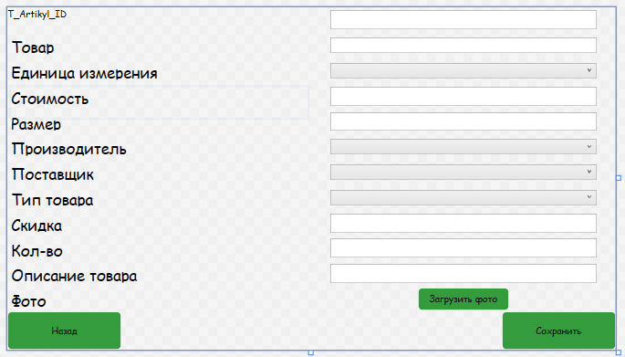

<Page x:Class="OOO_S_App.Pages.AddAndEditTovarPage"

xmlns="http://schemas.microsoft.com/winfx/2006/xaml/presentation"

xmlns:x="http://schemas.microsoft.com/winfx/2006/xaml"

xmlns:mc="http://schemas.openxmlformats.org/markup-compatibility/2006"

xmlns:d="http://schemas.microsoft.com/expression/blend/2008"

xmlns:local="clr-namespace:OOO_S_App.Pages"

mc:Ignorable="d"

d:DesignHeight="450" d:DesignWidth="800"

Title="AddAndEditTovarPage" Style="{DynamicResource base_page}">

<Grid>

<Grid.ColumnDefinitions>

<ColumnDefinition Width="*"/>

<ColumnDefinition Width="*"/>

</Grid.ColumnDefinitions>

<Grid.RowDefinitions>

<RowDefinition Height="*"/>

<RowDefinition Height="*"/>

<RowDefinition Height="*"/>

<RowDefinition Height="*"/>

<RowDefinition Height="*"/>

<RowDefinition Height="*"/>

<RowDefinition Height="*"/>

<RowDefinition Height="*"/>

<RowDefinition Height="*"/>

<RowDefinition Height="*"/>

<RowDefinition Height="*"/>

<RowDefinition Height="*"/>

<RowDefinition Height="50"/>

</Grid.RowDefinitions>

<TextBlock x:Name="ArtikylID" Text="T_Artikyl_ID" Height="40"/>

<TextBlock Text="Товар" Height="40" FontSize="20" Margin="5" Grid.Row="1"/>

<TextBlock Text="Единица измерения" Height="40" FontSize="20" Margin="5" Grid.Row="2"/>

<TextBlock Text="Стоимость" Height="40" FontSize="20" Margin="5" Grid.Row="3"/>

<TextBlock Text="Размер" Height="40" FontSize="20" Margin="5" Grid.Row="4"/>

<TextBlock Text="Производитель" Height="40" FontSize="20" Margin="5" Grid.Row="5"/>

<TextBlock Text="Поставщик" Height="40" FontSize="20" Margin="5" Grid.Row="6"/>

<TextBlock Text="Тип товара" Height="40" FontSize="20" Margin="5" Grid.Row="7"/>

<TextBlock Text="Скидка" Height="40" FontSize="20" Margin="5" Grid.Row="8"/>

<TextBlock Text="Кол-во" Height="40" FontSize="20" Margin="5" Grid.Row="9"/>

<TextBlock Text="Описание товара" Height="40" FontSize="20" Margin="5" Grid.Row="10"/>

<TextBlock Text="Фото" Height="40" FontSize="20" Margin="5" Grid.Row="11"/>

<Button x:Name="LoadPhotoBtn" Content="Загрузить фото" VerticalAlignment="Center" HorizontalAlignment="Center" Style="{StaticResource ButtonRadius}" Grid.Row="11" Grid.Column="1" Width="120" Height="30" Click="LoadPhotoBtn_Click"/>

<TextBox x:Name="T_Artikyl_ID" Width="350" Height="25" Grid.Column="1" Text="{Binding T_Artikyl_ID}"/>

<TextBox x:Name="SpisokCb" Grid.Row="1" Grid.Column="1" Text="{Binding T_Spisok_ID}" Width="350" Height="20"/>

<ComboBox x:Name="EdCb" Grid.Row="2" Grid.Column="1" SelectedItem="{Binding Ed_Izm}" DisplayMemberPath="E_Name" Width="350" Height="20"/>

<TextBox x:Name="T_Stoimost" Width="350" Height="25" Grid.Column="1" Grid.Row="3" Text="{Binding T_Stoimost}"/>

<TextBox x:Name="T_Razmer_Max_Skidki" Width="350" Height="25" Grid.Column="1" Grid.Row="4" Text="{Binding T_Razmer_Max_Skidki}"/>

<ComboBox x:Name="ProizCb" Grid.Row="5" Grid.Column="1" SelectedItem="{Binding Proizvod}" DisplayMemberPath="P_Name" Width="350" Height="20"/>

<ComboBox x:Name="PostvCb" Grid.Row="6" Grid.Column="1" SelectedItem="{Binding Postavchik}" DisplayMemberPath="P_Name" Width="350" Height="20"/>

<ComboBox x:Name="TypeCb" Grid.Row="7" Grid.Column="1" SelectedItem="{Binding Type_Tovara}" DisplayMemberPath="T_Name" Width="350" Height="20"/>

<TextBox x:Name="T_Destv_Skidka" Width="350" Height="25" Grid.Column="1" Grid.Row="8" Text="{Binding T_Destv_Skidka}"/>

<TextBox x:Name="T_Kolich" Width="350" Height="25" Grid.Column="1" Grid.Row="9" Text="{Binding T_Kolich}"/>

<TextBox x:Name="T_Opis" Width="350" Height="25" Grid.Column="1" Grid.Row="10" Text="{Binding T_Opis}"/>

<Button x:Name="back" Content="Назад" Grid.Row="12" Style="{StaticResource ButtonRadius}" Width="150" Height="50" VerticalAlignment="Center" HorizontalAlignment="Left" Click="back_Click"/>

<Button x:Name="save" Content="Сохранить" Grid.Row="12" Style="{StaticResource ButtonRadius}" Width="150" Height="50" VerticalAlignment="Center" Grid.Column="1" HorizontalAlignment="Right" Click="save_Click"/>

</Grid>

</Page>

AddAndEditTovarPage.xaml.cs

using OOO_S_App.Base;

using System;

using System.Collections.Generic;

using System.IO;

using System.Linq;

using System.Text;

using System.Threading.Tasks;

using System.Windows;

using System.Windows.Controls;

using System.Windows.Data;

using System.Windows.Documents;

using System.Windows.Input;

using System.Windows.Media;

using System.Windows.Media.Imaging;

using System.Windows.Navigation;

using System.Windows.Shapes;

using Microsoft.Win32;

namespace OOO_S_App.Pages

{

/// <summary>

/// Логика взаимодействия для AddAndEditTovarPage.xaml

/// </summary>

public partial class AddAndEditTovarPage : Page

{

//переменные для дальнейшей работы с фото

private Tovar _currentZakazchik = new Tovar();

public string _photoDirectory = $@"{Directory.GetCurrentDirectory()}\Images\";

private string _photoPath;

private string _photoName;

public AddAndEditTovarPage(Tovar selectedZakazchik)

{

//работа с данными БД для вывода данных

InitializeComponent();

_currentZakazchik = selectedZakazchik ?? new Tovar();

EdCb.ItemsSource = TradeEntities.GetContext().Ed_Izm.ToList();

ProizCb.ItemsSource = TradeEntities.GetContext().Proizvods.ToList();

PostvCb.ItemsSource = TradeEntities.GetContext().Postavchiks.ToList();

TypeCb.ItemsSource = TradeEntities.GetContext().Type_Tovara.ToList();

DataContext = _currentZakazchik;

}

private void back_Click(object sender, RoutedEventArgs e)

{

//кнопка назад

NavigationService.GoBack();

}

private StringBuilder CheckFileds()

{

//метод проверка вставленны ли данные для их сохранения

StringBuilder s = new StringBuilder();

return s;

}

private void save_Click(object sender, RoutedEventArgs e)

{

//кнопка для сохраниния с методотом проверки пустых значений

StringBuilder _error = CheckFileds();

if (_error.Length > 0)

{

MessageBox.Show(_error.ToString());

return;

}

try

{

if (_photoPath != null)

{

_currentZakazchik.T_Photo = _photoName;

File.Copy(_photoPath, _photoDirectory + _photoName);

}

_currentZakazchik.T_Ed_Izm_ID = (EdCb.SelectedItem as Ed_Izm).Ed_Izm_ID;

_currentZakazchik.T_Proizvod_ID = (ProizCb.SelectedItem as Proizvod).Proizvod_ID;

_currentZakazchik.T_Postavshik_ID = (PostvCb.SelectedItem as Postavchik).Postavchik_ID;

_currentZakazchik.T_Type_Tovar_ID = (TypeCb.SelectedItem as Type_Tovara).Type_Tovara_ID;

if (_currentZakazchik.T_Artikyl_ID != null)

{

TradeEntities.GetContext().Tovars.Add(_currentZakazchik);

}

TradeEntities.GetContext().SaveChanges();

MessageBox.Show("Запись изменена");

NavigationService.Navigate(new Pages.AdminPage());

}

catch (Exception ex)

{

//исключение ошибка для проверки самого прилжения

MessageBox.Show(ex.Message.ToString());

}

}

private void LoadPhotoBtn_Click(object sender, RoutedEventArgs e)

{

//кнопка загрузки фото из папки в приложение

OpenFileDialog openFileDialog = new OpenFileDialog();

openFileDialog.Filter = "JPG Files (*.jpg)|*.jpg|PNG Files (*.png)|*.png";

if (openFileDialog.ShowDialog() == false)

{

return;

}

FileInfo fileInfo = new FileInfo(openFileDialog.FileName);

if (fileInfo.Length > 8 * 1024 * 1024 * 6)

{

MessageBox.Show("Размер фото не должен превышать 6 мб");

return;

}

_photoName = Guid.NewGuid().ToString();

_photoPath = fileInfo.FullName;

}

}

}

Auth.cs

using System;

using System.Collections.Generic;

using System.Linq;

using System.Text;

using System.Threading.Tasks;

namespace OOO_S_App.Class

{

internal class Auth

{

//класс для автоматического изьятия ФИО из БД и вставление этой информации в проект

public static string U_Familya { get; set; }

public static string U_Imya { get; set; }

public static string U_Otchestvo { get; set; }

}

}

Captcha.cs

using System;

using System.Collections.Generic;

using System.Drawing;

using System.IO;

using System.Linq;

using System.Text;

using System.Threading.Tasks;

namespace OOO_S_App.Class

{

internal class Captcha

{

//класс для работы КАПТЧА

static public string CreateCaptcha(string fileName = "captcha.png")

{

Random rnd = new Random();

int height = 150;

int width = 200;

string abc = "qwertyuiopasdfghjklzxcvbnm1234567890";

string captcha = "";

for (int i = 0; i < 5; i++)

{

captcha = captcha + abc[rnd.Next(0, abc.Length)];

}

Bitmap image = new Bitmap(width, height);

Graphics graphics = Graphics.FromImage(image);

for (int i = 0; i < 100; i += 10)

{

graphics.DrawLine(Pens.DarkRed, new Point(i, i),

new Point(width - i, height - i));

}

graphics.DrawString(captcha, new Font("Arial", 15, FontStyle.Italic), Brushes.Black, new PointF(width / 2 - 42, height / 2 - 13));

image.Save(Directory.GetCurrentDirectory() + "\\Image\\" + captcha + ".png", System.Drawing.Imaging.ImageFormat.Png);

return captcha;

}

}

}

Manager.cs

using System;

using System.Collections.Generic;

using System.Linq;

using System.Text;

using System.Threading.Tasks;

using System.Windows.Controls;

namespace OOO_S_App.Class

{

internal class Manager

{

//класс для накладывание на окно страницу

public static Frame MainFrame { get; set; }

}

}

Model1.Context.cs

//создаем переменную для метода GetContext

private static TradeEntities _context;

//метод для импорта данных из основной БД

public static TradeEntities GetContext()

{

if (_context == null)

{

_context = new TradeEntities();

}

return _context;

}

Tovar.cs

//метод для поиска и импорта фото из папки images в проект

public string GetPhoto

{

get

{

if (T_Photo == null)

return null;

return Directory.GetCurrentDirectory() + @"\images\" + T_Photo.Trim();

}

}

//метод для подкрашивания данных с условием

public string GetColor

{

get

{

if (T_Destv_Skidka < 15)

return " #7fff00";

else

return "#fff";

}

}

//метод для просчитывание скидки и в последсвие вписание новой цены

public double ProductPriceWithDiscount

{

get

{

double p = Convert.ToDouble(T_Stoimost);

byte d = Convert.ToByte(T_Destv_Skidka);

double s = p * (100 - d) / 100;

return s;

}

}

public string GetTextDecotation

{

get

{

if (T_Destv_Skidka > 0)

return "Strikethrough";

return null;

}

}

Структура приложения

